**VISVESVARAYA TECHNOLOGICAL UNIVERSITY**

**JNANASANGAMA, BELGAVI-590018, KARNATAKA**



REPORT ON

**Medicine Inventory Tracking System**

Submitted By

Name: Usn:

Samhitha L V 4BD23CD035

Manasa M K 4BD23CD023

Meghana Jogar 4BD23CD025

Chinmayi R P 4BD23CD008

**Faculty Name: Head of the Department:**

Prof. Bharath H C Dr. Pradeep N

Assistant Professor Professor & HOD

Dept. of CS&E (Data Science) Dept. of CS&E (Data Science)



Department of Computer Science and Engineering (Data Science)

Bapuji Institute of Engineering and Technology Davanagere-577004

2024-25

**Vision**

To provide a quality and holistic education in data science, data analytics, data visualization, industry collaborations and research for empowering individuals to derive knowledge, thereby transform the potentials in data for the betterment of society.

**Mission**

|  |  |
| --- | --- |
| 1 | Educate and prepare students with a strong foundation in data science, equipping them with the skills, knowledge, and ethical principles needed to excel in  data-driven fields. |
| 2 | Foster collaborations with industries to adopt modern data science and visualization tools which solves the real-world problems that have societal benefits. |
| 3 | Cultivate a culture of life-long learning with intellectual curiosity in data science and nurturing individuals who are passionate about data-driven decision-making |

**Program Educational Objectives (PEOs)**

|  |  |
| --- | --- |
| 1 | Graduates will work in the area of applications of software development, Artificial Intelligence, Machine Learning, Data Analytics and Data Visualization. |
| 2 | Graduate will exhibit professional ethics and moral value with capabilities of working as an individual and as a team member in the corporate world to contribute toward the need of the dynamic requirements of industry and society. |
| 3 | Graduates will become responsible successful software professionals with leadership and managerial quality in the modern software industries based on their strong skills on theoretical and practical foundation. |

**Course objectives:**

|  |  |
| --- | --- |
| 1 | To Provide a strong foundation in database concepts, technology, and practice. |
| 2 | To Practice SQL programming through a variety of database problems. |
| 3 | To Understand the relational database design principles. |
| 4 | To Demonstrate the use of concurrency and transactions in database. |
| 5 | To Design and build database applications for real world problems. |
| 6 | To become familiar with database storage structures and access techniques. |

**Course outcomes (Course Skill Set):**

At the end of the course, the student will be able to:

|  |  |
| --- | --- |
| 1 | Describe the basic elements of a relational database management system |
| 2 | Design entity relationship for the given scenario. |
| 3 | Apply various Structured Query Language (SQL) statements for database manipulation. |
| 4 | Analyse various normalization forms for the given application. |
| 5 | Develop database applications for the given real-world problem |
| 6 | Understand the concepts related to NoSQL databases. |

**CONTENTS**

* **Chapter 1: Introduction**
  1. DESCRIPTION
  2. EXISTING SYSTEM
  3. PROBLEM STATEMENT
  4. PURPOSE SYSTEM
  5. OBJECTIVES
* **CHAPTER 2: LITRETURE SURVEY**

2.1 Overview of Existing Research

2.2 Technological Approaches

2.3 Gaps in Existing Literature

2.4 Conclusion

* **CHAPTER 3: SYSTEM REQUIREMENTS**

3.1 FUNCTIONAL REQUIREMENTS

3.2 NON-FUNTIONAL REQUIREMENTS

3.3 HARDWARE AND SOFTWARE REQUIREMENY

* **ENTITY – RELATIONSHIP DIAGRAM**
* **CONCLUSION**
* **CHAPTER 4: SCREENSHOTS**

**ABSTRACT**

The **Medicine Inventory Tracking System** is a computer program created to counter the essential challenges faced in the handling of drugs within healthcare facilities like hospitals, clinics, and pharmacies. Due to the increase in the volume of drugs on the market, monitoring their quantity and shelf life has become quite cumbersome. Most healthcare providers continue to use pen-and-paper systems or simple spreadsheets to keep track of their inventory, which ends up creating inefficiencies, expired stock, and the inability to have critical medicines available during critical points. The system proposed here plans to automate the entire process of inventory management through the implementation of a central platform that keeps all the medicine information in real time.

The system allows entry of key medicine information like name, batch number, quantity, date of manufacturing, and expiry date. As entered, the system constantly verifies stock levels and imminent expiry dates, sending alarms and notifications for timely action. The system further enables users to prepare detailed reports for analysis and decision-making for maximum inventory control.

By minimizing human error, avoiding the use of expired medicine, and ensuring effective stock rotation, the system improves patient safety and operational efficiency. It also facilitates compliance with regulatory and pharmaceutical standards. By automating and intelligence tracking, the system not only reduces costs associated with wastage but also enhances healthcare service delivery by having the right medicines available at the right time. This is particularly helpful for organizations handling large inventories that cannot be tracked manually. Overall, the Medicine Inventory and Expiry Tracking System is a clever, efficient, and scalable solution to enhance medicine management, ensure patient health, and streamline operations in the healthcare industry.

**1.INTRODUCTION**

In the medical field, access to medicines directly correlates with the health of patients and the outcome of treatment. Proper medicine inventory management is critical to ensure that required drugs are in stock when needed and expired or potentially toxic medicines are taken out of circulation. Yet, keeping a large inventory of products—each with its own batch numbers, expiration dates, and storage needs—is a huge challenge. The traditional practices, e.g., manual registers or spreadsheets, are widely practiced but are extremely inefficient for contemporary healthcare needs. They are error-prone, need constant manual monitoring, and do not have the real-time tracking capability to avert problems like stockouts or the consumption of expired drugs.

To overcome these issues, the **Medicine Inventory Tracking System** is presented as an integrated digital solution. It streamlines the essential processes of pharmaceutical inventory management, such as adding new stock, monitoring current levels of stock, and tracking expiry dates. The system minimizes dependence on human memory and manual verification by sending automatic reminders when stock is low or drugs are approaching their expiry date. These reminders prevent the use of expired drugs and ensure a continuous supply.

Besides optimizing operational efficiency, the system provides improved safety by guaranteeing health regulation compliance and reducing risks linked to obsolete medications. The system also supports real-time reporting generation, which facilitates effective planning and decision-making. This decreases monetary losses from expired stock as well as encouraging cost-effective procurement. Finally, the Medicine Inventory and Expiry Tracking System is a critical instrument in contemporary healthcare settings, ensuring medicines are handled, tracked, and utilized efficiently. It ensures institutions provide high-quality patient care by providing timely quality medication while minimizing the likelihood of human mistake and mismanagement.

**1.1 DESCRIPTION**

The **Medicine Inventory Management System** is a computerized software solution aimed at enhancing and simplifying the management of medicines' inventories in health facilities like hospitals, clinics, and pharmacies. The system's prime objective is to computerize the tracking of medications, with emphasis on stock quantities and expiry dates. This guarantees expired drugs are pulled out of inventory in a timely manner, and that critical drugs are stored when required, avoiding waste and the danger of dispensing expired medication.

The system functions by retaining crucial details for every medicine, such as its name, batch number, producer, quantity, and expiry date. When such data is entered into the system, it keeps track of the status of each item in real-time, giving accurate information on stock levels and expiry dates. When the stock begins to run low or an expiry date is near, the system sends automatic notices to inform the concerned personnel, encouraging them to restock or destroy expired products.

One of the most notable aspects of the system is its capacity to produce detailed reports, enabling users to quickly determine stock levels, near-term expirations, and inventory usage trends. These reports are beneficial for making decisions, particularly when preparing future stock orders or conducting audits. The system also features a friendly dashboard that gives a real-time snapshot of the inventory, enabling easy management and monitoring of large quantities of medicines in an efficient manner.

Also, the system has role-based access, where adding or modifying inventory information can only be done by authorized staff. This increases security and accountability in the healthcare facility. In general, the **Medicine Inventory Management System** provides greater control, minimizes human error, and enhances operating efficiency, which enables healthcare workers to attend more to patient care instead of inventory management.

**1.2 EXISTING SYSTEM**

Most health centres, hospitals, pharmacies, and clinics still utilize manual or half-manual techniques for tracking medicine inventories. Most current systems contain only registers of written accounts or rudimentary spreadsheets where they capture medicines, their stock numbers, batch numbers, and the dates when they expire. As low cost to effectuate, the approach remains laden with problems that might give rise to inefficiency, error, and unsafe risks.

These involve a lot of human effort and time to process and update files, tending to result in errors or even outdated data. For example, medicine levels will need to be updated by hand, and expire dates have to be inspected on a regular basis by staff members. It becomes a labour-consuming and error-susceptible task when keeping large amounts. Missing or incorrect input data can lead to expired drugs remaining in inventory, which could be inadvertently dispensed to patients with severe health consequences. Also, without automated warnings, employees will not know that critical drugs are reaching their expiry date until it is too late.

Also, manual systems do not provide real-time reports or allow following trends over time. For instance, stock reports, which are critical for procurement planning, can have to be manually prepared, resulting in inefficiencies and delays. Predicting future stock requirements also becomes problematic, as the lack of historical data or automated monitoring makes it hard to project future demands. This can lead to overstocking, which results in wasted resources and excess inventory, or understocking, resulting in stockouts and possible treatment delays.

In short, current systems are not in line with the new healthcare climate in which speed, accuracy, and regulatory compliance are key. The shortcomings of these systems underscore the necessity of a more powerful and automated system—such as the **Medicine Inventory Management System**—to make operations more efficient, safer, and better in terms of managing medical supplies.

**1.3 PROBLEM STATEMENT**

In healthcare, maintaining medicine inventory is important in ensuring critical medicines are always available, costs are kept within manageable limits, and wastages are controlled. However, effective inventory management is a major challenge for many healthcare centres.

**Key Challenges:**

1. **Stock Level Verification:** Manual tracking systems are inefficient due to human errors. This means stock on hand will not match what data shows. This would lead to stockout situations or overstocking. Both of these scenarios are not ideal as they increase costs and affect patient care.
2. **Process Effectiveness:** Streamlined processes allow inadequate staff ordering and supply locating which increases the time patients get care.
3. **Inventory Management Disturbances:** Global ever-changing dynamics like disasters, suppliers, and natural calamities disturb inventory management. Medical units often struggle to obtain essential supplies when their usual suppliers cannot deliver them, resulting in delays and shortages.
4. **Problem of Missing Up-to-Date Information:** Slow or out-of-date inventory information stifles responsiveness and effective decision-making. Moving to the cloud with real-time updates improve control and sight of inventory levels.
5. **Errors in Manual Input of Data:** Manual processes exponentially increase the chances of having inaccurate inventories. Errors can be reduced using automation, such as barcode scanning, thereby increasing precision.
6. **Ineffective Anticipating of Demand:** Underestimating or overestimating demand a business would lead to overstocking or stock shortages. Demand prediction can be improved through available data and predictive analytics.
7. **Problems With Integration:** Efficiency can suffer as a result of disparate systems, leading to silos. Linking together different inventory management systems to other software like ERP or CRM streamlines flow while also improving accuracy

**1.4 PURPOSE SYSTEM**

A Medicine Inventory Management System (MIMS) is software that helps monitor the movement, storage, and distribution of pharmaceutical products in a healthcare organization. It ensures safe handling and management of medicines so that patients receive the right care and the organization operates effectively.

**Main Functions of a Medicine Inventory Management Information System**

1. **Tracking Inventory in Real Time**

Stock control at MIMS is done in real time by utilizing barcode scanning and RFID technologies. Stock visibility reduces stockout and overstocking incidents. Medications will be available at the time of need without excess.

1. **Compliance to Regulations and Reporting**

MIMS assists health care facilities in meeting Non-therapeutic Expenditure (NTE) regulations by maintaining accurate records of medication usage, documenting controlled substances, and providing reports needed for audits and inspections.

1. **Optimize Costs and Use Resources Effectively**

With the help of MIMS, health care facilities are able to eliminate wasteful resource expenditure by understanding usage rates.

1. **Resource Allocation and Cost Efficiency**

MIMS provides the healthcare industry with analytics that assist in streamlining spending and purchasing by their usage trends and inventory turnover accuracy. This, in turn, allows for better resource allocation and reduction in wasteful spending.

1. **Improved Patient Safety and Care Quality**

Proper medication inventory management directly translates to having the medications ready when they are needed by the patients, thereby minimizing errors and increasing the standard of care provide.

As highlighted above, a Medicine Inventory Management System (MIMS) is a powerful asset to any healthcare institution, as it simplifies medication processes, assures compliance with applicable laws and regulations, aids in achieving better health outcomes, and supports overall organizational efficiency.

**1.5 OBJECTIVES**

**Objectives of a Medicine Inventory Management System**

1. **Ensure Continuous Availability of Medications**

MIMS guarantees that essential medicines are consistently available, preventing treatment delays and ensuring uninterrupted patient care.

1. **Optimize Stock Levels**

The system maintains optimal inventory levels by minimizing both overstocking and understocking, thereby reducing holding costs and preventing stockouts.

1. **Enhance Operational Efficiency**

By automating inventory processes, MIMS reduces manual errors, saves time, and allows healthcare staff to focus more on patient care.

1. **Ensure Regulatory Compliance**

The system helps healthcare facilities comply with industry regulations by maintaining accurate records and facilitating audits.

1. **Improve Financial Management**

MIMS provides insights into inventory usage and trends, aiding in cost control and informed decision-making.

**2. LITERATURE SURVEY**

**2.1. Overview of Existing Research**

Different researchers have looked into medicine inventory systems to address inefficiency in healthcare supply chains. For instance, Gupta et al. (2019) established an automated drug inventory system for hospitals based on barcode scanning. Their system greatly enhanced stock management by minimizing the use of expired medicines and timely restocking. Another research by Rahman and Ahmed (2020) proposed an IoT-based system that employed RFID tags and sensors to facilitate real-time monitoring and tracking of drug stock. Their research focused on automation to reduce human error and delays. These researches indicate that the integration of technology in medicine inventory management improves accuracy, efficiency, and cost savings. By tapping into key areas such as expiry tracking and stock optimization, these systems enable healthcare providers to prevent waste while ensuring dependable access to critical drugs. The recurring theme in this study is the imperative of automating medicine inventory systems in order to eliminate manual reliance and enhance patient safety and quality of service.

**2.2 Technological Approaches**

Contemporary medicine inventory systems utilize a number of technologies of major importance to enhance reliability, precision, and effectiveness. The majority of studies concur that Database Management Systems (DBMS) is of greatest significance in storing such important information as batch numbers, expiry dates, and quantities. Barcode and QR code scanners are extensively applied across the industry to enhance the automation of stock entry and retrieval tasks, eliminating human errors. Web and mobile applications provide remote access to inventory in real-time, allowing employees to check stock levels from afar. Cloud computing systems enable data to be stored centrally, which is useful for multi-site or branch companies. These technologies are aimed at streamlining processes and improving visibility, notifying users of restocking requirements and impending expiry dates. The literature proposes that the system must integrate these elements into a unified, easy-to-use platform in order to be effective. A common theme is the need for scalability and affordability, particularly for deployment in smaller hospitals or distant healthcare centers with limited IT infrastructure.

**2.3 Gaps in Existing Literature**

While numerous studies illustrate the benefits of automated inventory systems, significant gaps exist. Most current solutions are geared toward large hospitals with the resources and budget to accommodate sophisticated technologies. Small clinics and rural health centres are frequently left out of such systems because of their expense and complexity. A number of studies also point out that integration with other hospital systems-billing, procurement, and patient records—is frequently absent, leading to disjointed workflows. Additionally, all systems do not offer offline access, which is critical in networks with low connectivity. Training for users and post-deployment technical support are further issues often not addressed. In addition, another frequent issue is the absence of local language options and regional personalization. Such constraints imply that a one-for-all approach does not work well. Rather, systems must be flexible, low-weight, and cost-effective to accommodate various health environments. Closing these gaps is central to creating an inclusive and feasible inventory and expiry tracking solution.

**3. SYSTEM REQUIREMENTS**

A Pharmacy Inventory Management System needs to have a sound set of system requirements to make it effective and secure. The system's core should be able to provide central functional features like user authentication, stock tracking, management of sales and purchases, batch and expiry date tracking, and reporting. These features enable pharmacy personnel to track drug inventory levels, monitor expiration dates, create bills for customers, and maintain a computerized record of all transactions. Role-based access is critical to ensure that sensitive information or crucial operations are accessible only to authorized personnel.

Automated low stock and impending expiration alerts enhance efficiency and minimize the likelihood of stockouts or sale of expired drugs. Reporting functions assist in analysing sales trends, profitability, and inventory levels, which are important for sound business decisions. The system should also facilitate backup and restore features to avoid data loss in case of system failure.

Apart from functional characteristics, non-functional requirements guarantee the usability, performance, and long-term reliability of the system. The interface must be intuitive and easy to use for employees who do not necessarily have technical knowledge. Security is essential—data encryption, audit logs, and secure login procedures safeguard sensitive data. The system must be scalable to support future business expansion, such as opening more branches or expanding the volume of inventory.

Performance optimization is necessary to keep response times fast, even for large in datasets. Hardware requirements usually involve a computer with a recent processor, a minimum of 8GB RAM, and a good-quality SSD for storage. Software requirements include running on a stable operating system (such as Windows or Linux), a reliable database system (such as MySQL or PostgreSQL), and a robust backend and frontend technology used to build it. Together, these requirements form a solid basis for a sound pharmacy inventory solution.

**3.1 FUNCTIONAL REQUIREMENTS**

These state what the system must do

1. User Authentication and Roles

* Admin login
* Pharmacist login
* Role-based access control

2. Inventory Management

* Add, edit, delete medicine records
* Track stock levels
* Auto-update stock on sales/purchase
* Low stock alerts

3.Medicine Details Management

* Store drug name, type, batch number, expiry date, manufacturer, price, etc.
* Barcode integration.

4. Sales and Billing

* Create bills for customers
* Add discounts and taxes
* Print or send invoice via email

5. Purchase Management

* Log new stock from suppliers
* Update stock upon purchases
* Handle purchase orders
* 6. Expiry and Batch Management
* Monitor medicine batches
* Alert for impending expirations

7. Backup and Restore

* Automatic or manual data backup
* Restore functionality

**3.2 NON-FUNCTIONAL REQUIREMENTS**

These determine the quality features of the system,

1. Usability  
    User-friendly interface for non-technical users
2. Performance  
   Quick response time for big inventory   
   Optimized search process
3. Reliability  
   System to operate 24/7 with minimal down-time
4. Security

Role-based access  
Password encryption  
Audit logs

1. Scalability  
   Ability to support additional branches or users in the future
2. Maintainability  
   Simple to update or correct bugs.
3. Backup and Recovery  
   Daily automated backups should be kept and stored for a minimum of 30 days.  
   Recovery Time Objective (RTO) should be under 1 hour.  
   Recovery Point Objective (RPO) should be under 15 minutes.
4. Availability  
   The database should be available 24/7 with maintenance windows scheduled outside business hours.

**3.3 HARDWARE REQUIREMENTS**

* **Processor**: Intel i5 or higher
* **RAM**: 8 GB or more
* **Storage**: 256 GB SSD or higher
* **Display**: 1080p monitor
* **Printer**: For invoice printing
* **Barcode**: Scanner

**SOFTWARE REQUIREMENTS**

* **Operating System**: Windows 10/11 or Linux (Ubuntu)
* **Database**: MySQL / PostgreSQL / SQLite
* **Backend**: PHP / Java / Python / Node.js
* **Frontend**: HTML, CSS, JavaScript
* **Web Server**: Apache / XAMP/WAMP
* **Browser**: Chrome / Firefox (for web-based systems)

**ENTITY-RELATIONSHIP DIAGRAM:**

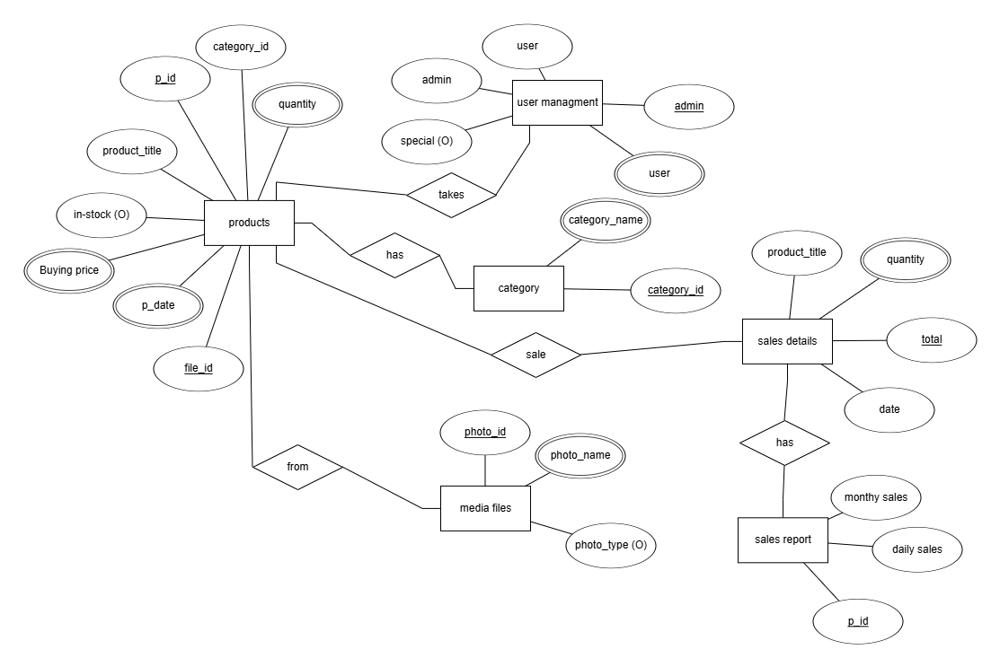

FIG 4.0: Medicine inventory system ER diagram

**4. SCREENSHOTS**

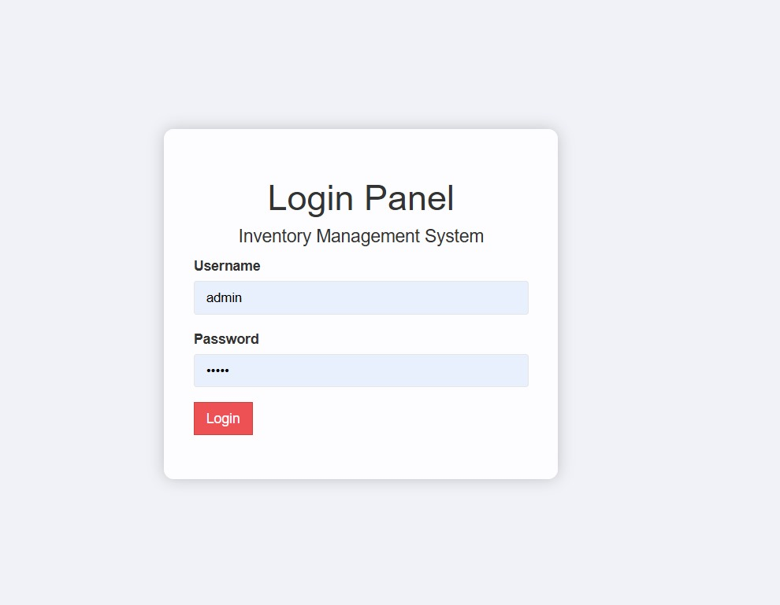

Fig 4.1 Login Page: Username – admin, Password- admin

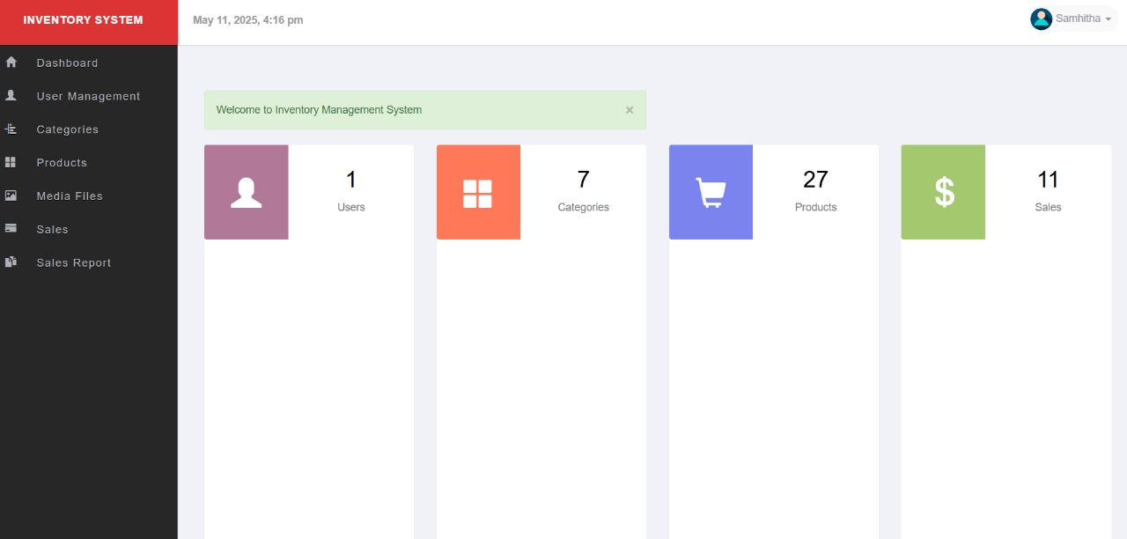

Fig 4.2: Home Page with Dashboard

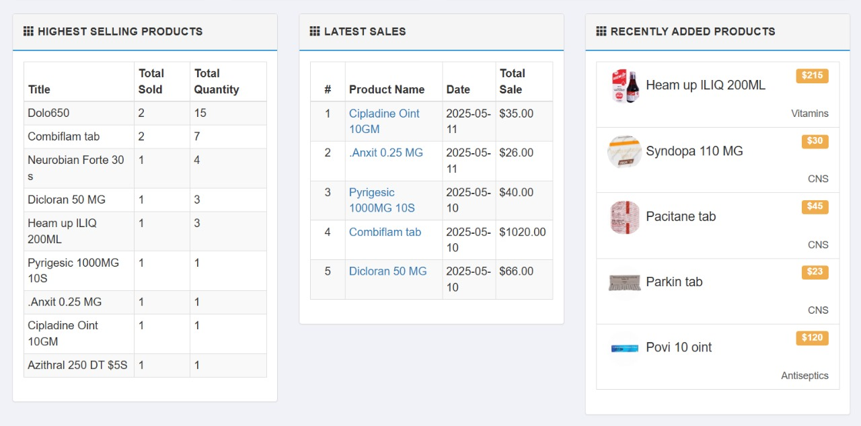

Fig 4.3: Home Page

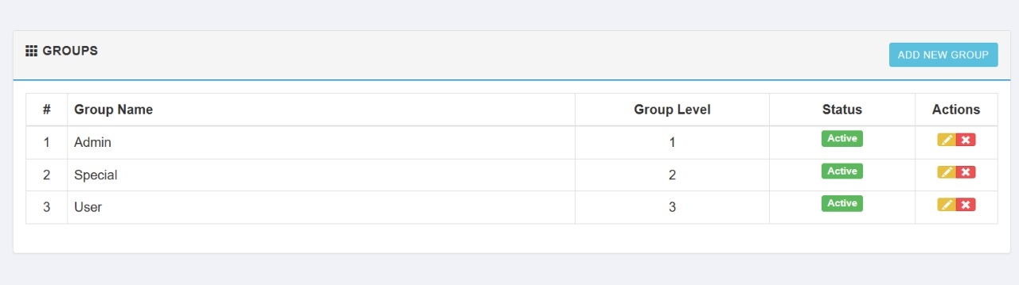

Fig 4.4: User Management- manage groups

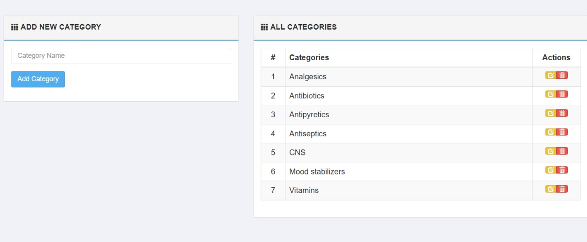

Fig 4.5 Category

Fig 4.6: Products- manage products

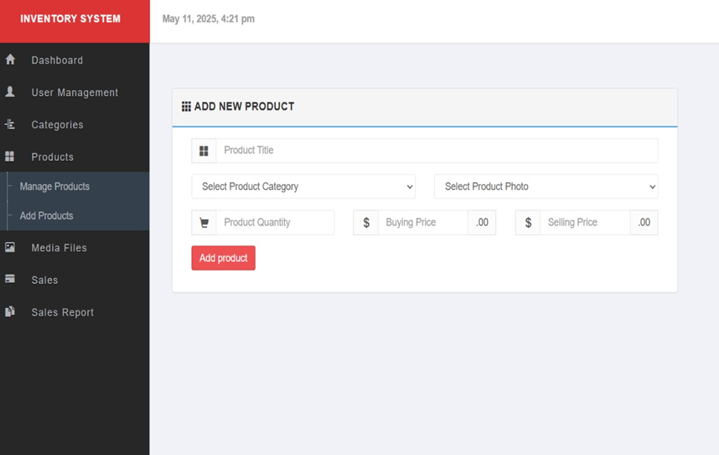

Fig 4.7: Products- Insert new products

Fig 4.8: Media Files

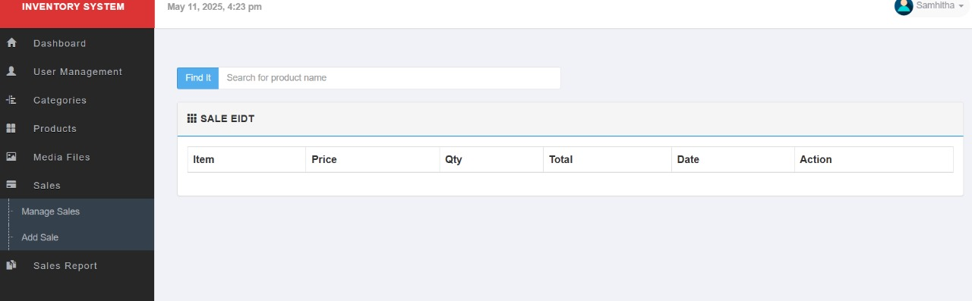

Fig 4.9: Sales- Insert Sales

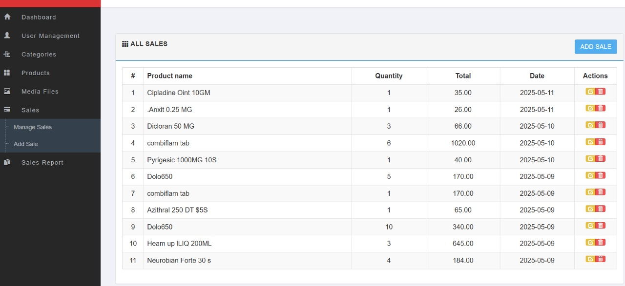

Fig 4.10: Sales – manage sales

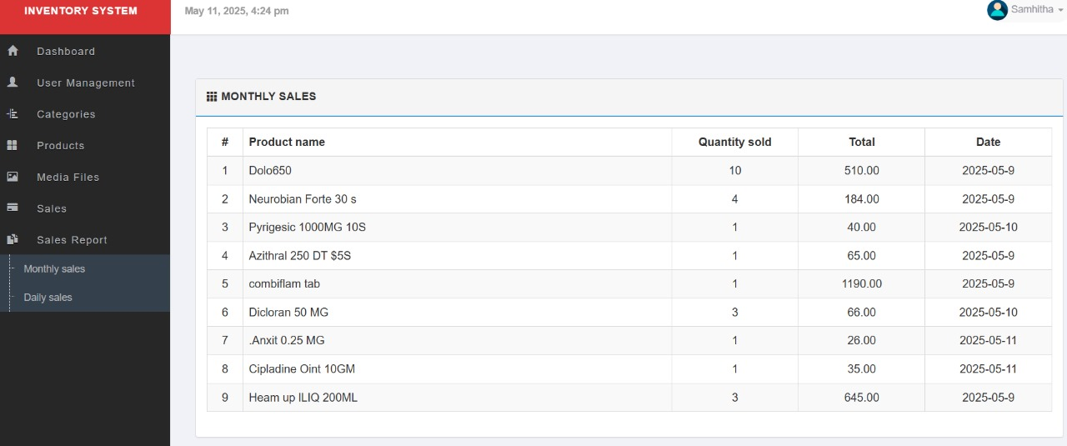 4.11: Sales report – monthly report

**Conclusion**  
The creation of a Medicine Inventory Tracking System fills an essential gap in the healthcare industry: effective management of medical inventory and timely detection of expired medicines. From research, surveys, and a literature review, it is clear that most healthcare facilities, especially in rural or underprivileged regions, continue to use antiquated manual tracking systems. These systems are susceptible to human error, lead to medication wastage, and can potentially compromise Patient safety.   
  
Automated systems, as discussed in several studies, have numerous benefits like real-time visibility of stocks, expiry alerts, and data-driven restocking. Nevertheless, the expense and complexity of some current solutions render them unsuitable for smaller clinics. The system proposed here aims to break these barriers by providing a low-cost, easy-to-use, and simple platform that can be used in various healthcare environments.  
  
The project not only eliminates the possibility of expiring drugs being dispensed but also optimizes overall stock control, allowing employees to take prompt, accurate decisions. Also, the system supports improved patient outcomes, compliance with regulations, and effective resource use.  
  
In summary, the adoption of an automated inventory and expiry tracking system is a critical step towards the modernization of healthcare supply chains. The system's capacity to reduce waste, avoid health hazards, and increase operational efficiency makes it an invaluable resource for any medical facility. Potential future additions might include integration with billing systems, multilingual support, and mobile app capability to further broaden its usefulness among a wider range of users and settings.